LGA Perceptions Survey 2013

Purpose of report

For decision and noting.

Summary

This report sets out the results of the 2013 perceptions survey and asks the LGA Leadership Board to agree the headline principles of the action plan (Appendix A).

Recommendation

That the Leadership Board notes the results of the 2013 perceptions survey and agrees the headline principles of the revised action plan for 2014.

Action

As directed by Members.

Contact officer: | David Holdstock
Position: | Director of Communications
Phone no: | 020 7664 3056
E-mail: | David.Holdstock@local.gov.uk

LGA Perceptions Survey 2013

Introduction

- This is the second year we have undertaken a perceptions survey of our membership. This comprehensive, cross-cutting research provides us with a benchmark to inform future work and give us a good understanding of the current views of member authorities. In addition, it helps us to better understand their views on the benefits of membership, their priorities, sector-led improvement, how well informed they feel about the work of the LGA and areas for improvement.

Summary

- Overall, the results show significant improvements compared to 2012 in all of the key areas. Respondents are more satisfied with the work we undertake on their behalf, believe we are more influential in shaping the agenda for local government and think we have become more effective at representing the views of our members. Importantly, more feel that we offer good value for money. They also agree that we address the issues that are important to councils and that we have been an effective advocate for the interests of local government.

- There are significant increases since 2012 in the extent to which respondents understand the purpose of the LGA and how we work for local government. Knowledge and awareness of the LGA and the work we undertake has increased significantly. However, as in 2012 there are some variations, depending on specific job role. ‘Backbench’ councillors’ are more likely to have the least knowledge of the LGA.

- Significantly more respondents say they would ‘speak positively about the LGA to others’ than in 2012 and more say they are satisfied with our work on behalf of local government.

- As in 2012, the services that are seen as most important are those related to our national role lobbying on behalf of local government.

- More people believe we keep them well informed about our work compared with 2012.

- The strong links between feeling informed and overall satisfaction are reinforced with 77 per cent of respondents feeling informed about the LGA and our work. The main methods of communication from which respondents get their information are First magazine, events, media work, our website, bulletins (Chairman, Chief Executive, board and political group office bulletins) and publications (such as Rewiring).

- There is high level of awareness of Rewiring Public Services (78 per cent).

- This year, for the first time, we asked a series of questions about the Centre for Public Scrutiny and Local Partnerships. Around half of the respondents have heard of the Centre for Public Scrutiny and Local Partnerships. Of those who were aware their council had used the services, the majority were satisfied or very satisfied with the service they had received.

- Although there has been a significant increase in the number of people who feel we demonstrate value for money (from 43 per cent to 53 per cent), this is still comparatively very low when compared to other areas. Although the number who disagree that we demonstrate value for money is relatively small (10 per cent), the focus of our work over the next year will need to be on the 38 per cent who ‘neither agree/disagree’ or ‘don’t know.’ In addition, further work needs to be undertaken to focus on backbench councillors in the coming year. In all areas, they are less likely to understand our work, feel well informed about the work we undertake on behalf of councils, feel we demonstrated value for money and to be advocates of the LGA.

Key findings

Question | 2012 | 2013 | % point change
I would speak positively about the LGA | 63% | 73% | +10%
Satisfied with the work of the LGA on behalf of the local government sector | 62% | 70% | +8%
The LGA demonstrates value for money for the funding it receives | 43% | 53% | +10%
The LGA is influential in shaping the agenda for local government | 62% | 68% | +6%
The LGA effectively represents the views of its members to central government | 69% | 77% | +8%
The LGA stands up for and defends the reputation of local government | N/A | 85% | N/A
The LGA addresses the issues that are important to councils | 79% | 83% | 10%
The LGA is transparent and accountable to its members | 58% | 66% | +8%
The LGA understands what councils need to help them improve their services and organisational capacity | 68% | 77% | +9%
I know ‘a fair amount’ or ‘a great deal’ about the LGA. | 61% | 72% | +11%
How well informed do you feel about the work of the LGA | 69% | 77% | +8%

- There continues to be a high level of knowledge and awareness (72 per cent) of the LGA and satisfaction with the work we undertake (70 per cent). In response to questions about our overall reputation, a high proportion of respondents (73 per cent) would speak positively about the LGA.

- The majority of respondents (81 per cent) also believe we are an effective advocate for the sector.

- Respondents rated the following activities as ‘very or fairly important’:

  - Providing a single voice for local government (94 per cent).
  - Managing local government’s reputation in the national media (93 per cent).
  - Supporting and promoting councils which are trying to transform services to better support their communities (92 per cent).
  - Providing support and challenge for councils to improve (91 per cent).

- All of these have seen increases since 2012.

- Two thirds of respondents agree that sector-led improvement is the right approach in the current context. This shows a slight increase (from 58 per cent to 62 per cent) on the 2012 figures.

- There are some regional variations in responses to individual questions but across the full range of questions the findings are fairly consistent in all parts of the country.

- Council leaders and chief executives are more likely to know more about the detail of what we offer and more likely to be satisfied. Two thirds of respondents say they benefit from being members of the LGA. Again, this is higher amongst leaders and chief executives than it is for backbench councillors, chairs of scrutiny and directors.

- In terms of political groupings, there are very few differences. Labour respondents are more likely to feel engaged with the LGA and Conservative respondents are more likely to agree their council is making advances in driving improvement.

Objectives

- This research was undertaken to:

  - Quantify member authorities' understanding of the LGA and what the LGA currently offers. This includes levels and channels of awareness, understanding of functions perceived to be part of the LGA’s remit, and how effective the LGA is seen at fulfilling these functions.

  - Investigate what our members want from the LGA and how they want to engage. This aspect provides feedback on a strategic level in terms of the organisation’s role and responsibilities but also on a tactical level in terms of formats and channels preferred.

  - Assess levels of awareness/views of sector-led improvement within local government, and views on support offered by the LGA. The research identifies areas where we might enhance its support in this area, by investigating the membership’s preferences and experiences of support, the impact that such support and the resources we provide to support sector-led improvement.

- Compare with the results of the 2012 survey.

Methodology

- Telephone Interviews were conducted by BMG Research on the LGA’s behalf with a sample of 917 representatives from councils across all regions. These included:

  - Council leaders.
  - Portfolio holders.
  - Chairs of scrutiny.
  - Backbench councillors.
  - Chief executives.
  - Directors.

- This has given a strong, representative sample allowing detailed analysis by role and region. The sample size has a maximum standard error of +/-3.1% at the 95% level of confidence, giving these findings a high level of accuracy. Interviews took between 15 and 20 minutes and explored:

  - Our offer and current provision;
  - Our current role and priorities and how these can be developed;
  - Effectiveness of our communications and preferred methods of engagement; and
  - Sector-led improvement within local government, our support offered to members and how it can be developed/improved.

- Some two answer options have been merged for simplicity. This may mean results appear to be a slightly different percent than that reported.

Table 1 - Respondents, by region, role and amalgamated role type

Amalgamated role: | Officers |  | Frontbench Councillors |  |  | Backbench Councillors | Regional  Total
Role: | Chief Executives | Directors | Leaders | Chairs of Scrutiny | Portfolio Holders | Backbench  Councillors
East | 14 | 38 | 11 | 14 | 8 | 41 | 126  (14%)
East Midlands | 13 | 25 | 11 | 12 | 10 | 42 | 113  (12%)
London | 6 | 31 | 2 | 11 | 11 | 30 | 91  (10%)
North East | 5 | 11 | 3 | 6 | 11 | 30 | 66  (7%)
North West | 11 | 23 | 8 | 10 | 11 | 30 | 93  (10%)
South East | 16 | 38 | 19 | 19 | 3 | 50 | 145  (16%)
South West | 7 | 18 | 16 | 10 | 11 | 30 | 92  (10%)
West Midlands | 9 | 31 | 8 | 8 | 15 | 30 | 101  (11%)
Yorkshire and the Humber | 6 | 23 | 11 | 11 | 19 | 28 | 90  (10%)
Role Total: | 87  (10%) | 238  (26%) | 81  (9%) | 101  (11%) | 99  (11%) | 311  (34%) | 917  (100%)
Amalgamated role Total: | 325 (35%) |  | 281 (31%) |  |  | 311 (34%) | 917  (100%)

Detailed analysis of the findings

- The following gives a more detailed analysis of the findings, showing where there are significant differences between different roles, regions or where there have been significant changes since the 2012 survey.

Knowledge of the LGA

- Knowledge of the LGA is high with 72 per cent of people saying they know a ‘fair amount’ or ‘a great deal’ about the LGA. This is a significantly higher proportion than in 2012 (61 per cent).

- Leaders and chief executives are particularly likely to be knowledgeable about the LGA, with backbenchers least likely to feel they ‘know a great deal about it’.

Table 2 - How well would you say you know the LGA?

Understanding of the purpose of the LGA

- Understanding of the purpose of the LGA is very high. Nine out of 10 respondents (91 per cent) agree with the statement ‘I understand the LGA’s purpose and how it works for local government.

- The number of frontbench councillors and officers who agree ‘a great deal’ has increased significantly since 2012.

- The South West (47 per cent), North West (46 per cent) and East Midlands (45 per cent) are most likely to agree ‘a great deal’, with those in London and the South East least likely to do so (both 32 per cent).

Table 3 – To what extent do you agree or disagree with the statement ‘I understand the LGA’s purpose and how it works for local government’?

Advocacy

- Seventy two per cent say they would ‘speak positively’ about the LGA to others (either spontaneously or if asked). This is a significantly higher proportion than in 2012 (63 per cent). Only four per cent of respondents said they would speak negatively about the LGA to others.

- Respondents in the South West are particularly likely to speak positively about the LGA (84 per cent), while those in the North West are more likely to have spoken negatively about the LGA (8 per cent).

Table 4 – Which of these phrases best describes the way you would speak of the LGA to other people? (*denotes less than 0.5%)

Satisfaction with the work of the LGA on behalf of local government

- Seventy per cent are either ‘fairly’ or ‘very satisfied’ with our work on behalf of local government. This represents a significant increase on 2012 (62 per cent). Only 2 per cent of respondents report being ‘very dissatisfied’ with the work of the LGA.

- There has been a significant improvement in satisfaction amongst officers within the last 12 months (75 per cent compared to 62 per cent in 2012 ‘fairly/very satisfied’) while the figures only suggest a slight increase amongst frontbench councillors (from 66 per cent in 2012 to 69 per cent in 2013).

- Four-fifths of leaders (79 per cent) and chief executives (80 per cent) are satisfied with the work of the LGA on behalf of local government. This contrasts with 67 per cent of chairs of scrutiny and 63 per cent of portfolio holders.

- Satisfaction is highest within the East (76 per cent) and the South West (76 per cent) and lowest in the North East (59 per cent), South East (62 per cent) and North West (63 per cent).

Table 5 - Overall, how satisfied or dissatisfied are you with the work of
the LGA on behalf of the local government sector? (*denotes less than 0.5%)

LGA capabilities

- Respondents are particularly likely to agree that we stand up for and defend the reputation of local government (85 per cent) and that we address the issues that are important to councils (83 per cent).

- More than three-quarters agree that we understand what councils need to help them improve their services and organisational capacity (77 per cent); effectively represents the views of our members to central government (77 per cent); and help to set and drive improvement in local government (76 per cent). There has been significant improvement since 2012 in each of these respects.

- Fifty three per cent agree that we provide value for money, which is a significant improvement on last year (43 per cent).

Table 6 - To what extent do you agree or disagree with the following
statements?

Table 7 – Agreement with the capabilities of the LGA - Comparison between 2012 and 2013 research

 | Total |  | Officers |  | Frontbench Councillors |  | Backbench Councillors
 | 2012 (937) | 2013 (917) | 2012 (333) | 2013 (325) | 2012 (293) | 2013 (281) | 2012 (311) | 2013 (311)
Agree the LGA address the issues that are important to councils | 79% | 83% | 84% | 87% | 77% | 81% | 72% | 81%
Agree the LGA understands what councils need to help improve their service and organisational capacity | 68% | 77% | 71% | 78% | 70% | 79% | 65% | 72%
Agree the LGA demonstrates value for money for the funding it receives | 43% | 53% | 39% | 53% | 47% | 55% | 44% | 50%
Agree the LGA is influential in shaping the agenda for local government | 62% | 68% | 66% | 70% | 61% | 69% | 59% | 66%
Agree the LGA stands up for and defends the reputation of local government | - | 85% | - | 87% | - | 85% | - | 81%
Agree the LGA effectively represents the views of its members to central government | 69% | 77% | 73% | 80% | 67% | 77% | 66% | 74%
Agree the LGA helps to set and drive improvement in the local government sector | 71% | 76% | 71% | 76% | 70% | 80% | 72% | 72%
Agree the LGA is transparent and accountable to its members | 58% | 66% | 52% | 63% | 60% | 68% | 61% | 67%

- East Midlands respondents are significantly more likely than most to strongly agree that the LGA ‘addresses the issues that are important to councils’ (45 per cent, compared with an average of 32 per cent); that it effectively represents the views of its members to central government (41 per cent, compared with a sample average of 27 per cent) and that it is transparent and accountable to its members (33 per cent compared with 22 per cent).

- South East respondents are significantly more likely than those in other regions to disagree that the LGA ‘understands what councils need to help them improve their services and organisational capacity’ (16 per cent, compared with an average of 8 per cent) and that it is ‘transparent and accountable to its members’ (16 per cent, compared with 9 per cent).

- East Midlands and South West respondents are significantly more likely than average to strongly agree that the LGA ‘demonstrates value for money for the funding it receives’ (both 24 per cent, compared with an average of 16 per cent).

- Respondents in the Yorkshire and the Humber region are significantly more likely than those elsewhere to strongly agree that the LGA ‘helps to set and drive improvement in the local government sector’ (36 per cent compared with an average of 23 per cent).

Extent to which the LGA been an effective advocate for the interests of local government

- The majority of respondents (81 per cent) believe that the LGA has been an effective advocate for the interests of the local government sector.

- Respondents in the East, South West and North East are most likely to believe the LGA has been an effective advocate while those in London and the North West are least likely to believe this is the case.

- Council leaders are particularly likely to be positive about the LGA as an effective advocate for local government.

Table 8 – Based on what you know, to what extent, if at all, has the LGA been an effective advocate for the interests of the local government sector?

Benefits of relationship with the LGA

- When asked the extent to which they believe their authority benefited from its relationship with the LGA, more than half (67 per cent) reported ‘a fair amount’ or ‘a great deal’. The proportion responding that their organisation benefits ‘a great deal’ is significantly higher (15 per cent) than in 2012 (11 per cent).

- Respondents in the South West are significantly more likely than those in most other regions to say their authority benefits from its relationship with the LGA (82 per cent compared with an average of 67 per cent).

Table 9 – To what extent would you say your authority benefits from its relationship with the LGA?
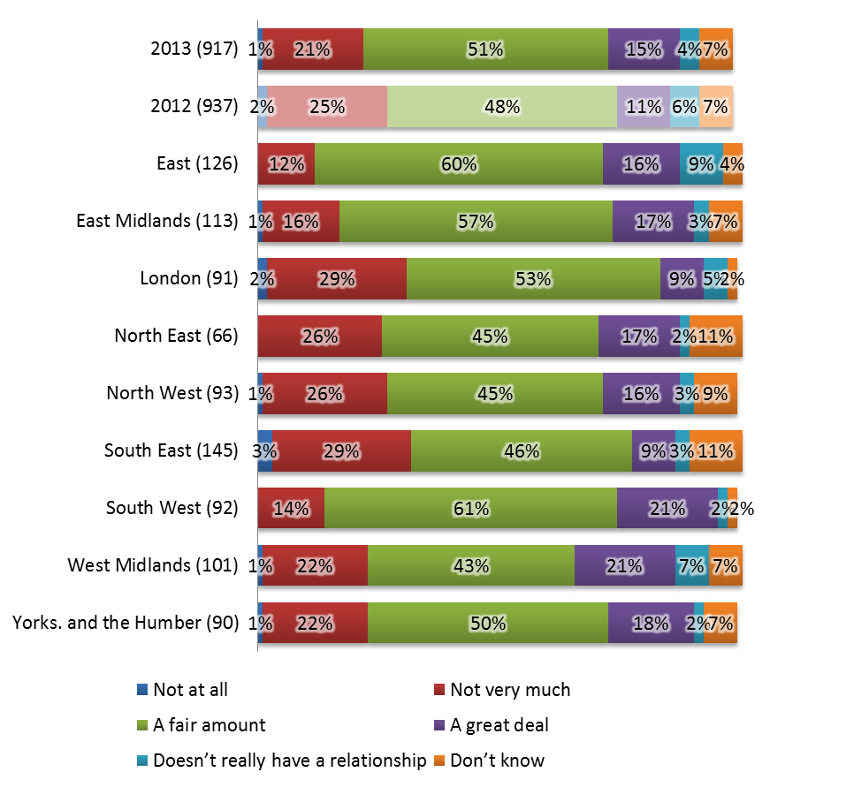

- Respondents who reported that their authority ‘did not benefit at all’ or ‘not very much’ were asked why they believed this was the case. Their responses are summarised below:

Table 10 – You said your authority benefits ‘not very much’ or ‘not at all’ from its relationship with LGA (* denotes less than 0.5%)
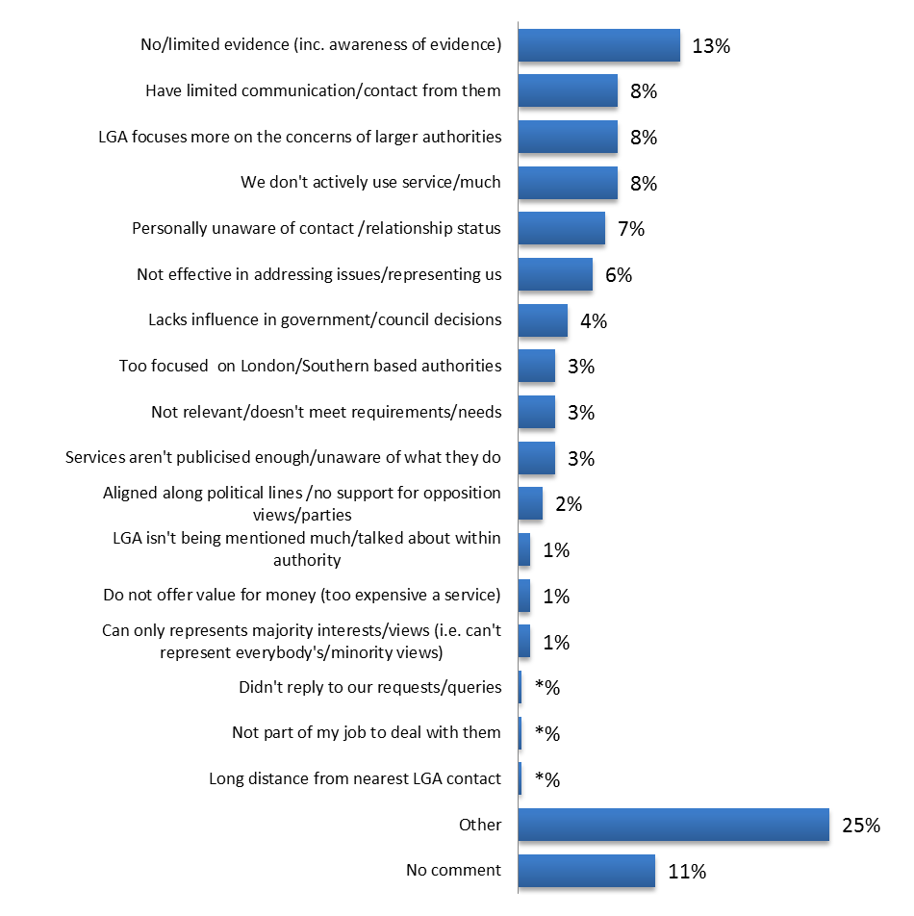

Activities conducted by the LGA

- The majority (90 per cent) of respondents believe all of the activities listed below are important to their authority or the sector. They are most likely to consider ‘providing a single voice for local government’ as the most important activity (94 per cent).

- Leaders are particularly likely to consider providing support and challenge for councils to improve as very important (56 per cent compared with an average of 49 per cent).

- Chairs of scrutiny are more likely to consider managing local government’s reputation in the national media as unimportant (11 per cent, compared with an average of 6 per cent).

Table 11 – I am going to read out a list of activities conducted by the LGA. For each, I would like you to tell me whether they are important or not to your authority or the sector?

Table 12 - What is the most important activity conducted by LGA?

Services provided by the LGA

- Lobbying on behalf of local government is considered particularly useful with 92 per cent considering it a ‘very useful’ or ‘useful’ service.

- Respondents who selected more than one activity as ‘very useful’ were asked which they saw as most useful. The activities viewed as most useful were:

  - lobbying on behalf of local government (32 per cent);
  - providing up-to-date information about local government (13 per cent); and
  - providing support for sector led improvement (12 per cent).

- These are similar findings to those reported in 2012.

- Officers are significantly more likely than frontbench councillors and backbench councillors to find lobbying on behalf of local government most useful (41 per cent compared with 29 per cent and 27 per cent respectively).

- The proportion is particularly high amongst chief executives (52 per cent).

Table 13 – Now I am going to read a list of services provided by the LGA. For each, please could you tell me whether they are useful or not to your authority?

Table 14 – Which of the following services is most useful to your authority?

LGA communications

- The majority of respondents (77 per cent) believe we keep them at least fairly well informed. This is a significantly higher than in 2012 (69 per cent).

- Respondents are significantly less likely to believe that the LGA only gives them a limited amount of information now than they were 12 months ago (17 per cent compared with 24 per cent).

- Chief executives and portfolio holders are particularly likely to feel very well informed (41 per cent and 36 per cent respectively). This proportion is also relatively high amongst council leaders (32 per cent).

- Backbench councillors are more likely than officers to believe they are not well informed (26 per cent compared with 18 per cent).

- Respondents in the East Midlands (40 per cent) and South West (36 per cent) are most likely to believe they are very well informed.

- Those in the South East (17 per cent) and West Midlands (19 per cent) are least likely to believe this to be the case.

Table 15 - How well informed, if at all, do you think the LGA keeps you about its work?

Channels of communication

- As in 2012, respondents reported that they find about the work of the LGA in a range of different ways. First magazine is most frequently mentioned (67 per cent) as was the case in 2012). Other important sources of information include events (50 per cent), media work (49 per cent) and website (47 per cent).

- Frontbench councillors are most likely to find out about the LGA’s work through events (47 per cent), media work (44 per cent), publications (41 per cent) and face-to-face contact (28 per cent).

- Backbench councillors most frequently cite media work (36 per cent) as how they find out about the LGA’s work.

- Officers are most likely to find out about the LGA’s work through events (70 per cent), media work (65 per cent) and publications (60 per cent).

Table 16 - How do you generally find out about the work of the LGA?

Preferred channels of communication

- First magazine is the preferred channel (21 per cent), followed by the Chairman’s weekly bulletin (19 per cent) and the Chief Executive’s bulletin (18 per cent).

- For frontbench councillors (22 per cent) and backbench councillors (39 per cent) First magazine is most frequently mentioned as their preferred source of information), followed by the Chairman’s weekly bulletin (21 per cent) and the Chief Executive’s bulletin (19 per cent).

- Officers prefer to find out about our work through e-bulletins (15 per cent) and cite the Chief Executive’s bulletin as the preferred method of finding out about our work (22 per cent). Our website is also popular with officers (14 per cent).

Table 17 – How would you prefer to find out about the work of the LGA?

Awareness of the LGA’s Rewiring Public Services campaign

- More than three-quarters of respondents (78 per cent) have heard of the Rewiring Public Services campaign.

- Respondents in London and the South East are most likely to be unaware of the campaign (31 per cent and 29 per cent respectively).

- Awareness is highest in the South West (83 per cent), the East Midlands (85 per cent) and Yorkshire and the Humber (83 per cent).

- Leaders and chief executives are more likely know ‘a great deal about the campaign’ (26 per cent and 31 per cent) compared to other roles.

- Frontbench councillors and officers are significantly more likely than backbench councillors to know at least a fair amount about the campaign (37 per cent, 42 per cent and 14 per cent respectively).

- A third of backbench councillors (33 per cent) and chairs of scrutiny (35 per cent) have never heard of the campaign.

Table 18 – How much do you know about the LGA's Rewiring Public Services campaign?

Engagement and contact with the LGA

- Nearly half (48 per cent) ’feel engaged’, which is a slight increase on 2012 (38 per cent).

- Leaders and chief executives are significantly more likely than those in other roles to be very engaged with the LGA (20 per cent and 29 per cent respectively).

Table 19 – How engaged do you feel you are with the LGA?

How do respondents engage with the LGA?

- Respondents reported a range of ways that they engage with the LGA:

  - Responding to LGA consultations (50 per cent);
  - Attending LGA events (48 per cent);
  - Contributing in LGA meetings/seminars (39 per cent); and
  - Contacting LGA officers by email or phone (37 per cent).

- This is very similar to 2012.

Table 20 – By what means do you engage with the LGA?

- Frontbench councillors and officers are significantly more likely than backbench councillors to engage with the LGA through visits from LGA councillors and staff to their council (38 per cent, 44 per cent and 17 per cent respectively).

- Frontbench councillors are most likely to engage with the LGA by attending LGA events (51 per cent) and responding to LGA consultations (50 per cent).

- Backbench councillors are most likely to engage with the LGA by responding to consultations (33 per cent) and through magazines (including ‘First’) (13 per cent)

- Officers are most likely to engage with the LGA by responding to LGA consultations (66 per cent), attending LGA events (66 per cent), contributing to LGA meetings/seminars (56 per cent), contacting LGA officers by email or phone (54 per cent), when contacted by LGA officers or in their role as an advisor (39 per cent), face-to-face (38 per cent), acting as an LGA peer or supporting LGA development programme (26 per cent).

Sector-led improvement

- Sector-led improvement continues to be seen as the right approach to continuous improvement. Sixty two per cent agree that the approach to sector-led improvement is the right approach in the current context. This is a slightly higher proportion than in 2012 (58 per cent).

- Eighty eight per cent agree that their authority is making advances in driving improvement. This is a higher proportion than that reported in 2012 (83 per cent).

- The proportion of respondents who agree that local accountability is strong in their authority is similar (85 per cent) to 2012 (83 per cent).

- There continues to be variations in awareness of our sector-led improvement offer. Nearly half of respondents (44 per cent) have ‘heard a lot’ or ‘a moderate’ amount about sector-led improvement. This shows a slight increase on 2012 (41 per cent).

- Officers are significantly more likely to be aware of sector-led improvement than frontbench and backbench councillors (32 per cent compared with 11 per cent and 6 per cent respectively).

- The proportion of chief executives that have ‘heard a lot’ about sector-led improvement is significantly higher than average (61 per cent).

- Those in the South East are most likely to have heard ‘a little/nothing’ (64 per cent) about sector-led improvement.

Table 22 – How much, if anything, have you heard about the sector-led improvement approach?

Table 22 - Comparison between 2012 and 2013 (proportion who agree or strongly agree with the statements)

 | Total |  | Officers |  | Frontbench members |  | Backbench members
 | 2012 (937) | 2013 (917) | 2012 (333) | 2013 (325) | 2012 (293) | 2013 (281) | 2012 (311) | 2013 (311)
The approach to sector-led improvement is the right approach in the current context | 59% | 62% | 68% | 71% | 56% | 58% | 51% | 56%
My authority is making advances in driving improvement | 84% | 88% | 91% | 97% | 89% | 91% | 71% | 77%
Local accountability is strong in my authority | 83% | 85% | 89% | 94% | 89% | 87% | 73% | 74%

- Respondents in Yorkshire and the Humber are more likely than average (16 per cent) to disagree that the approach to sector-led improvement is the right approach in the current context

- The proportion of respondents who strongly agree that ‘local accountability is strong in my authority’ is higher than average in the North East (64 per cent).

Capacity for continuous improvement

- The majority of respondents (87 per cent) are at least moderately confident that their authority has the capacity to monitor its own performance and continuously improve. This is similar to 2012 (85 per cent).

- Most frontbench councillors (91 per cent) and officers (92 per cent) are confident that their authority is able to monitor its own performance with a view to continuously improving, one in five backbench councillors (20 per cent) are not confident that this is the case.

- Confidence is highest in the East Midlands (58 per cent) and lowest in the West Midlands (20 per cent).

Table 23 – To what extent would you say you are confident that your own authority currently has the necessary skills and capacity to monitor its own performance and continuously improve?

- Four-fifths of respondents (80 per cent) are confident that the local government sector has the necessary skills and capacity to monitor its own performance and continuously improve. This is similar to the figure in 2012.

- Respondents in the East Midlands are most confident (35 per cent) and those in the North East (20 per cent’) least confident.

Table 24 - To what extent would you say you are confident that the local government sector currently has the necessary skills and capacity to monitor its own performance and continuously improve?

Awareness and satisfaction with the Centre for Public Scrutiny

- More than half the respondents (54 per cent) have heard of the Centre for Public Scrutiny (CfPS).

- Of those who were aware of their councils’ use of services provided by the CfPS, 79 per cent are satisfied with them.

- Backbench councillors are significantly less likely than officers and frontbench councillors to have heard of the CfPS (42 per cent compared with 54 per cent and 66 per cent respectively).

- Awareness is significantly higher amongst chief executives (79 per cent) and chairs of scrutiny (76 per cent).

- The proportion of respondents who had heard about the CfPS is highest in the South West (61 per cent) and North West (58 per cent).

- The proportion is lowest in the South East (45 per cent).

Table 25 – How satisfied or dissatisfied are you with the services provided by the Centre for Public Scrutiny?

Awareness and satisfaction with Local Partnerships

- Nearly half the respondents (47 per cent) had heard of Local Partnerships.

- Of those who are aware their council have used services provided by Local Partnerships, 78 per cent are satisfied with them.

- Frontbench councillors are less likely than officers and backbench councillors to have heard of Local Partnerships (44 per cent compared with 49 per cent and 47 per cent respectively).

- Awareness is significantly higher amongst chief executives (67 per cent).

- Awareness is highest in the North East (56 per cent) and lowest in the West Midlands (39 per cent) and the South East (41 per cent).

- Respondents in the East Region are most likely to be satisfied (90 per cent) while those in the South East and West Midlands are least likely to be (both 71 per cent).

Table 26 – How satisfied or dissatisfied are you with the services provided by Local Partnerships?

Conclusions

- These results represent a significant improvement on last year in all of the key areas. The action plan agreed by Leadership Board in 2012, which focused on improving awareness of our offer to councils, protecting and enhancing the reputation of local government and lobbying has played a part in improving awareness and satisfaction.

- Satisfaction across all areas has improved with people more likely to speak positively about the LGA and our work. Awareness of the LGA and the work we undertake has increased. Although there have been improvements across all areas, backbench councillors remain the least engaged. However, the overall proportion of those who know just a little about the LGA has decreased significantly. This suggests that work we undertook as part of last year’s action plan to increase people’s awareness and understanding has been successful.

- The increase in understanding since 2012 also extends to a better understanding of the purpose of the LGA and how it works for local government.

- The increased understanding may have impacted on the overall satisfaction with the LGA as significantly more respondents report that they would best be described as speaking positively about the LGA to others (either spontaneously or if asked) than in 2012 and that they were fairly or very satisfied with the LGA’s work on behalf of the local government sector. Respondents are also more likely to think they benefit a great deal from their relationship with the LGA.

- As in 2012 the services delivered by the LGA that are perceived to be of the most importance to respondents tend to be related to the national role the LGA has in lobbying on behalf of the local government sector.

- A significantly higher proportion of respondents believe the LGA keeps them well informed about their work compared with 2012. However, there is still some work to do in this area to target those who do not feel we keep them well informed. Further work to target backbench councillors will be undertaken.

- The issue of how effectively we demonstrate value for money requires further work as this is still an area where we still need to improve. This can be achieved across all areas of the business and will need to be a key focus of our work in the coming months as this is one of the key drivers of reputation.

- There continues to be mixed awareness of the sector-led improvement approach although awareness has increased slightly. Respondents continued to agree this was the correct approach and significantly more believe their local authority had made steps to drive improvement than in 2012. Respondents were slightly more confident in their authority’s and the 116. Local government sector’s capacity to monitor their own performance and continuously improve than in 2012.

Next steps

- Work will now be undertaken to refresh last year’s action plan to address the outstanding issues that have come out of this year’s survey. The work to engage backbench councillors will be further developed to ensure all members, whether they play a leading role in their council or undertake a ward function understand the key activities and benefits of being a member of the LGA. An awareness campaign will be developed to raise awareness of our sector-led improvement offer. This will focus on the individual components of our offer so that councils understand the full range of the support available to them and on the benefits.

- Work is already underway to further enhance First magazine and develop the on-line version. We are also developing a series of briefing sessions and updates for principal advisors and their teams so that they can focus on key issues for their area.

- The action plan attached at Appendix A has been updated and builds on the existing plan agreed by Leadership Board in 2013.

